ARMY MOUNTAINEERING ASSOCIATION

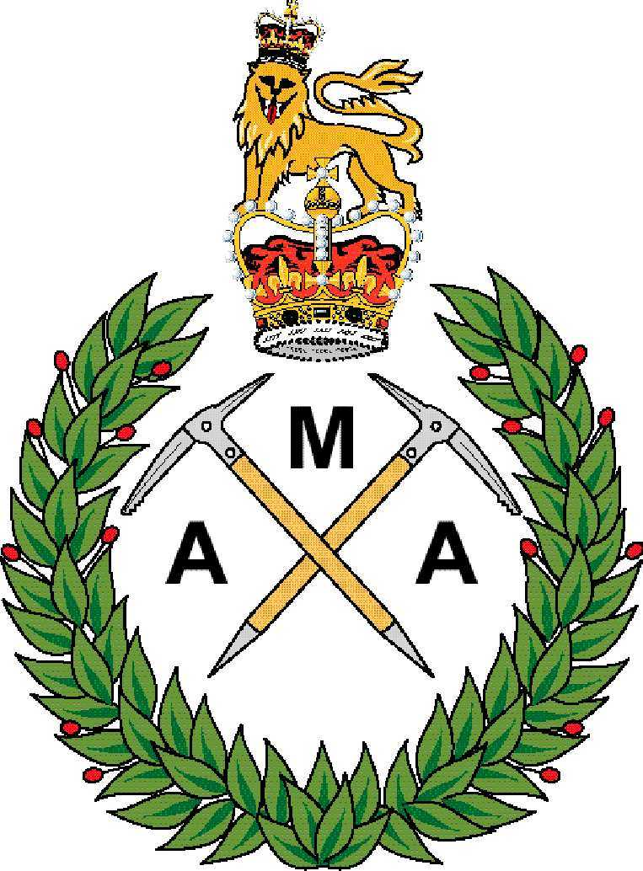

SAFETY MANAGEMENT PLAN 2023

RECORD OF AMENDMENTS Change Number | Authority | Amendment Date | Amendment (s)
1 | WO2 Brant | 1 Sep 19 | 1. Re-write of entire plan.
2 | WO2 Brant | 01 Apr 20 | 1. Inclusion of COVID-19 into RA.
3 | WO1 Brant | 17 Feb 21 | 1. Refinement of COVID-19 procedures.  2. Update to policy: Inclusion of ACSO 1200.
4 | WO1 Brant | 10 Aug 22 | 1. Update to policy throughout.  2. Removal of COVID-19 protocols throughout  3. Update of Climatic Injury sections.  4. Review of impact scoring – All RAs  5. Inclusion of following hazards in to all RAs: Sudden Cardiac Arrest (SCA), Exertional Heat Illness (EHI), Exertional Rhabdomyolysis, Exertional Collapse, Associated with Sickle-Cell Trait (ECAST) and Asthma attack.
5. | Capt (MAA) Brant | 02 May 23 | 1. Refinement of assurance procedures and Inclusion of 1st Party Assurance Question Set @ Appendix 1.  2. Inclusion of Army Sport Ops within the post incident information chain Annex B.
AMA Committee and Members Area of Website

ARMY MOUNTAINEERING ASSOCIATION SAFETY MANAGEMENT PLAN 2023

Introduction

1. All AMA activity is to be conducted as ‘On Duty’ activity; either as Adventure Training (AT) or Sport. As a result, all activity is to be conducted in accordance with the relevant JSP, policy and supporting best practice (governing body). The need for AMA activity to be conducted as On Duty excludes non-serving AMA members to be part of mountaineering, and sports climbing activities. Non-serving AMA members can attend social events, including the Annual General Meeting (AGM) and Presidents Dinner, but do so at their own liability. Key references for AT are JSP 419 & AGAI Vol 1 Chap 11. Key References for Sport are JSP 660 and AGAI Vol 1 Chap 5. Risk assessments are contained at Annex A and Safety Procedures at Annex B.

Aim

- The aim of this document is to provide direction and guidance on the safe management of all Army Mountaineering Association (AMA) activities to ensure that any associated risks to injury or death are identified and properly managed to ‘As Low as Reasonably Practicable’ (ALARP) and tolerated. It is the personal responsibility of all leaders and instructors involved in organising and conducting AMA activity are to ensure that they ensure an acceptable duty of care is in place.

Context

- As part of the ALARP process, all AMA activity is to be conducted as ‘On Duty’ activity; either as Adventure Training (AT) or Sport. As a result, all activity is to be conducted in accordance with the relevant JSP, policy and supporting best practice as issued and recognised by our governing organisations for On-Duty Activity; most notably ATG(A) for Adventure Training, and the Army Sports Control Board (ACSB). In the case of Sport, the Army endorsed policy is for this to be managed by following the guidance of the respective governing body. This plan is therefore written to be complementary to the latest policy direction and guidance; which is always subject to change. It is therefore the responsibility of the event organiser to ensure that they are up to date on current policies and practices; or to seek advice and guidance as required. The need for AMA activity to be conducted as On Duty excludes non-serving AMA members to be part of mountaineering, and sports climbing activities. This does not exclude their attendance at social events, including the Annual General Meeting (AGM) and Presidents Dinner, but do so at their own liability. It is also for the event organiser and participant to ensure that they are registered on their respective Part One Orders to ensure individuals are registered as being on duty for authorised AMA activity.

- In addition to following Defence/Army policy, the national governing body (NGB) for Mountaineering and Climbing is the British Mountaineering Council. Both ATG(A) and ACSB recognise the BMC as the appropriate NGB for Mountaineering and Climbing. The AMA is to therefore ensure it follows best practise as provided by the BMC. The BMC participation statement is: “The BMC recognises that climbing is an activity with a danger of personal injury or death. Participants in climbing activities should be aware of and accept these risks and be responsible for their own actions and involvement.” Further guidance on safe practice can be found in the BMC’s ‘Risk, Responsibility, Duty of Care and Liability – Club Guidelines’ document which is available on their website: www.bmc.co.uk

Key Reference Documents

- Whilst not necessarily an exclusive list, the following is a summary of the key reference documentation that must be adhered to when conducted AMA activity:

a. Implementation of Defence Policy for Health, Safety and Environmental Protection: DSA 01.2

b. Management of Health and Safety in Defence: JSP 375

c. Adventurous Training in the Armed Forces: JSP 419

d. AGAI Vol 1 Chapter 11: Adventurous Training

e. Army’s Safety and Environmental Management System: ACSO 1200

f. Defence Direction and Guidance for Training and Education: JSP 822

g. Sport in the UK Armed Forces: JSP 660

h. AGAI Vol 1 Chapter 5: Sport

AMA Safety Governance Structure

- AMA activity is divided into three distinct areas: General Mountaineering, Sport Climbing and Non-Mountaineering. Responsibility for ensuring the appropriate Safety Framework is in place for all AMA events conducted under these umbrellas is delegated by the AMA Chairman:

  - General Mountaineering: Delegated to Vice Chairman Mountaineering; who may also sub-delegate management of Meets to the Meet Committee Representative.

  - Sport Climbing: Delegated to Vice Chairman Sport Climbing.

  - Non Mountaineering: Delegated to AMA General Secretary; for example, social events which can also be attended by non-serving personnel, including the AGM (meet and social element only) and the Presidents Dinner.

- The incumbent of each of these appointments is to ensure that all nominated event organisers who are the lead for AMA sponsored activity are responsible for ensuring that the appropriate Safety Management Framework is in place. Where appropriate, this also includes having a nominated Activity Owner. In some cases, the Vice-Chair for Sports Climbing will also be responsible for conducting Climbing under the rules of AT, for example, the Army Festival of Climbing. The key determining factor is whether there is a competitive element to it; if so, it falls under the rules of Sport. If individuals are unsure of whether their event is AT or Sport, they are to seek further guidance from either the AMA Committee, ACSB or ATG(A) as appropriate.

8. JSP 419, Part 1 Para 63 also gives specific guidance on the conduct of Service Association Meets. All AMA weekend Meets must be conducted in accordance with JSP 419 as an On-Duty activity. This includes production of a JSATFA, Generic Risk Assessments (examples contained within Annex A), nomination of an appropriate Activity Owner, and admin instructions (to include telling attendees to ensure their attendance is captured on Part One Orders), Daily Risk Assessments and (in accordance with the template within Annex A). It is formally acknowledged that Meets may require the use of civilian instructors, which if used, must meet the criteria laid out in JSP 419 Para 18; most notably the organiser must obtain proof of 3rd party liability insurance, relevant/endorsed qualifications for the activity and be medically fit to undertake the required activity.

Process of Safety and Risk Management

9. Guidance on the completion of risk assessments is covered in more detail in Annex A. The VC, or their empowered representative, is ensure this guidance is issue to all AMA event organisers and instructors. As highlighted above, the aim is to ensure that any associated risks to injury or death are identified and properly managed to ‘As Low as Reasonably Practicable’ (ALARP) and tolerated. Common to all activity is the need to adopt a Safe Systems of Work: Safe Persons, Safe Practices, Safe Place and Safe Equipment. More details can be found in JSP 419 (Para 37), JSP 375 (Vol 1, Ch 40), whilst ACSO 1200 provides specific guidance on the assessment and management of risk. It is important that all event organisers are familiar with, and follow the latest guidance laid down in these documents.

10. It is mandatory for a risk assessment is to be conducted and recorded, with the key points being briefed as appropriate before activity commences as part of the safety brief. For sports climbing events, given that they are held at commercial venues and are conducted in a more controlled environment, it is recognised that the risk assessment may change little between events, however it is still important that a safety brief is conducted to ensure due diligence and for those new to the activity and environment. Complacency and over familiarity is to be avoided.

Duty of Care and Activity Owner

11. Activity conducted as Joint Services Adventurous Training (JSAT). A new system of DH was implemented in Jan 21 which is based on the Duty of Care (DoC) system this introduces a series of levels know as; Activity Owner, Activity Deliverer and Activity Lead who are accountable and responsible for the safety management of AT. The ACSO also states where any participants in an activity are not usually under direct command of the Activity Owner it is a multi-unit activity that ‘The Activity Owner and their OPCOM CoC are responsible for the planning and conduct of the activity and the CoC of the participants have the legal obligation under DoC to ensure the participants are sufficiently prepared to do so’. The CO of the lead unit is responsible for appointing a suitable Officer, Warrant Officer or NCO to be responsible for the Duty of Care of all participants and providing assurance as requested by contributing units. This includes ensuring supporting risk assessments and medical plans are endorsed by the Activity Owner to ensure the quality of the documentation and the stated risk mitigation methods.

12. In the case of AMA activity, wherever possible, the Activity Owner is to be the respective CO of the individual leading the activity to allow for greater oversight of the planning, risk management and assurance process. Additionally, this allows for risk escalation up the chain of command if required. In the event of a CO not being willing to assume Activity Owner responsibilities, the Chairman of the Association could be authorised to conduct this role; however, event organisers are requested to first approach their own chain of command as in most cases they are both geographically best placed to do so as this is more about ensuring that the right processes and procedures are being followed. The ACSO/process clearly allows for attendees to come from external units; it is more about supervision of the organisation/organiser.

13. Activity conducted as a Sport. As highlighted in ACSO 1200, Ch 4, para 14, footnote 68, AMA activity conducted as Sport will be governed the Army Sport Control Board (ASCB) rules, which use the safety standards set by the respective National Governing Body (NGB); which for climbing, is the British Mountaineering Council (BMC). Sports climbing will therefore not require a nominated Activity Owner, however it remains a Chain of Command responsibility to adhere to their legal duty of care (DoC) responsibilities when their soldiers participate in sport. In order to ensure the safe conduct of AMA run sport climbing activity, events are still to be conducted within the instructor ratios laid down in JSP 419.

Post Incident Management

14. More details on post incident management are contained within Annex B. This includes a useful template in the unlikely event of an incident occurring; it is recommended that event leaders carry this card with them. It also contains more specific guidance on the reporting of both Accidents and Incidents. In the event of an accident or incident taking place on an AMA activity the formal reporting activity is still to be followed.

15. Incident Report. Any accident must be reported by raising a NOTICAS (JSP 751 Vol 1, Part 1, Ch 2) through the respective unit which has provided the Activity Owner for the activity. In the event of needing to report an incident or matter of public interest, units are to also follow ACSO 1200. This includes sending an Incident Report (INCREP) through the lead unit. All accidents, incidents, near misses and unsafe acts must be reported via the Defence Unified Reporting and Lessons System (DURALS). In order to send an alert, access the Defence Gateway via your mobile device and proceed to the Defence Alert page/App that can be found on the front screen

16. Matters of Public Interest. Where an occurrence has happened that may be of Public Interest, this is to be reported to the AINC using the Army occurrence notification and copied to the respective unit which has provided the Activity Owner CoC and Duty Officer.

Medical Action Plan

17. When conducting JSAT activity expedition leaders are to ensure they have included a Medical Action Plan. Advice should be sought from the relevant ATDO to confirm if a separate medical plan is required, or if it can be incorporated within the admin instruction and risk assessment. Specialist and specific advice can be obtained through Lt Col Pate Davis, who is both an AMA Committee Member and qualified/experienced SME. In addition, a Medical Special Interest Group has been formed in conjunction with ATG(A) which will also be able to provide advice. Scrutiny and governance of the medical action plan will be through the normal JSATFA clearance process, which in the case of a High Risk and Remote (HR&R) activity, will result in an HR&R panel.

Assurance

18. To be accountable for our actions, the AMA and event organisers need to be prepared to be subject to external scrutiny and assurance. If requested to do so, the AMA will comply with all external agencies tasked with carrying out assurance/external validation of our activities and any supporting recommendations. For Sports Climbing the AMA will carry out 1st Party assurance and a template can be found at Appendix 1, 2nd and 3rd Part assurance will be initiated through the Army Sport, and for AT through HQ ATG(A) and through the wider Army and Defence CoC as appropriate.

Pete Davis

P Davis
Lieutenant Colonel
Chairman - Army Mountaineering Association

Annexes:

A. Risk Management.
B. Post Incident Management.

APPENDIX 1 TO
ARMY MOUNTAINEERING ASSOCIATION SAFETY MANAGEMENT PLAN 2023
DATED 02 MAY 23

ASCB REPRESENTATIVE SPORT 1ST PARTY ASSURANCE (1PA) QUESTION SET (QS)

1. Assurance processes provide a mechanism to ensure that sport activity is being conducted appropriately and to provide a handrail for those engaged in authorising, organising or assuring sport activity.

2. This QS must be completed at least annually and is to be forwarded to the SAO ASCB.

Sport/Discipline: Completed by: Date:

1st LoDA–This is internal assurance; it is also known as 1st Party Assurance (1PA) and is to be conducted by those responsible for delivering the sport to measure their own levels of conformity. All sports should nominate a 1PA Officer.
Ser | Activity | Y/N | Comment
 | Completion of the Sports Appointment Course or equivalent.
 | Completion of a Risk Assessment for all activities.
 | Sport delivery is iaw and compliant with JSP 660, AGAI Vol 5 & ACSO 1200.
Compliance with NGB Rules & Regulations (specific to sport).
(Often the MOD or single Service requires a higher standard)
 | Activity (Risk) Owner – Chair authorises each sport activity iaw Chap 4 ACSO 1200 and DoC. Therefore, ensuring activity is correctly authorised and recorded.
 | Activity Deliverer - Nominated for each sport activity iaw Chap 4 ACSO 1200.
 | Activity Lead - Use of SQEP individuals (Coaches and Officials) to supervise activity as required iaw Chap 4 ACSO 1200.
 | Production and compliance of an in-date (annually) Sport Safety Management Plan (SSMP).
 | Production of a detailed Administration Instruction (for all events).
 | Ensuring activity is correctly authorised and recorded.
 | Use of SQEP individuals (Coaches and Officials) to supervise activity.
 | Provision of adequate activity medical arrangements.
 | Authorised use of Service travel entitlements.
 | Discourage Substance Misuse and report offenders.
 | Adherence with Army Sponsorship regulations (where applicable).
 | Adherence to own Sports 1st LoDA, including data capture of such visits.
 | Nominate a DURALS person for each event/activity. All occurrences (Accidents/Incidents) of any level of severity or outcome, Unsafe Act/Condition, Dangerous Occurrence, Near Miss or Fatality are to be submitted on DURALS. Investigations and recommendations are to be raised against the DURALS occurrence report.
 | Submit activity reports (when requested)
2nd LoDA – This is the assurance oversight provided by HQ ASCB and is also known as 2nd Party Assurance (2PA) in order to ensure adherence to wider MoD policy and that those involved are complying with Army and NGB policy for Army Representative Sport. 2PA Visits are conducted by the Safety & Assurance Officer (SAO).
18 | A chain of command management check of those delivering the respective sport activity against the criteria listed at serials 1-17 above. Sports will be notified in advance of a 2PA Visit.
3rd LoDA- Assurance conducted by external auditors and regulators.
19 | For Army Representative Sport, a 3PA Visit will be delivered by an external 3rd party, such as the appropriate NGB or the Defence Safety Advisor (DSA). Sports will be notified in advance of a 3PA Visit.

ACSO 1200 Chapter 4 Para 14 Footnote 68: Representative Sport. The Army Sport Control Board (ASCB), Directors of representative sport and appointed coaches etc may be better placed as the SRM chain for these activities rather than linked to the OPCOM CoC.
Hill Walking, Summer and Winter Mountaineering, skiing (including ski touring and mountaineering), Rock and Ice Climbing.
All competitive climbing activity including indoor climbing, ice climbing and bouldering competitions as well as any training activity required to prepare teams for these events.
Event with no mountaineering content such as meetings, dinners and seminars.
ACSO 1200 Chapter 4 gives more detail.
ACSO 1200 Chapter 4 Para 13
As per ACSO 1200 Chapter 4 Para 14: a specific SRM C2 would have to be endorsed to enable the AMA Chair to become the Activity Owner.
The committee can be used to brief CoC if required.

